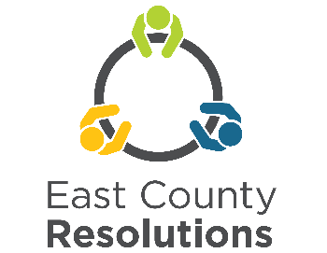 | Conflict Management Training  September 4-6th, 2024  Application due Aug. 19th, 2024

This 16-hour Conflict Management Training is held over three days; Wednesday, Thursday and Friday. Participants must attend all training days as each builds on the prior days’ lessons. The training is held virtually by Zoom.

Schedule: | Wednesday, Sept. 4, 9:00-3:30 p.m. Thursday, Sept. 5, 9:00-3:30 p.m.  Friday, Sept. 6, 9:00 a.m.-1:00 p.m.
Please fill out this application, answer the questions and send them with attached pages to be received by August 19, 2024.

Name:

Address:

Phone number: Day Cell

E-mail address:

What cost option are you applying for? (Please check one box)

❑ $400 training at full cost
❑ $200 training with commitment to utilize the skills as a community leader,
❑ $25 I am applying for 1 of 4 scholarships as a community-based organization that provides direct services to vulnerable and underserved populations in east Multnomah County (Fairview, Wood Village, Gresham, Troutdale, Unincorporated east Multnomah County).
❑ No cost I am a City of Gresham, Fairview, Troutdale, Wood Village employee

Hardship waivers available for those living or working in our service area.

Please answer the following questions if you are applying for a reduced rate scholarship.

- Which area is you or your agency located? (Please check one)
Troutdale Wood Village Gresham Fairview Unincorporated East Multnomah County

- Please explain how your agency serves vulnerable and/or underserved communities in east Multnomah County or how you, yourself represent a vulnerable and/or underserved community.
_______________________________________________________________________________

_______________________________________________________________________________

_______________________________________________________________________________

_______________________________________________________________________________

_______________________________________________________________________________

3. How did you find out about this training?

_______________________________________________________________________________

4. The following information is voluntary and useful to us in forming a balanced group of trainees.

Age: _______ Gender: _______ Race/Ethnic group: __________________

